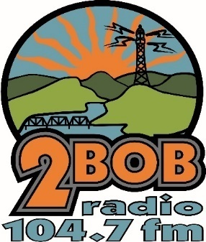
2 BOB Community Radio 104.7
Manning Media Co-Operative Ltd
PO Box 400 Taree NSW 2430
Phone: 02 6552 6200
Fax: 02 6552 7196
Email: admin@2bobradio.org.au

2017 Supporter Application

2 BOB Supporter for individual’s options:
2BoB Gold Supporter $30 (one fee for all)
- get an album (your pick from 100 to select from)
- go in the daily draw for a jackpot lottery ticket
- 2bob car sticker
- Access to all on air giveaways
- Receive info on the happenings at 2bob
- Discount on 2bob merchandise
- For new presenters - a discount on training fees
2BoB Silver Supporter$10
- get 2 cd singles (your pick from 100 to select from)
- go in the daily draw for a jackpot lottery ticket
- 2bob car sticker
- go in the draw for all on air giveaways
I am interested in being involved in 2BOB Community Radio as:
Gold Supporter ($30.00) _____Silver Supporter ($10.00)______
Name: __________________________________________ Date: __________________
Address: _________________________________________________________________
_________________________________________________________________________
Phone: ________________________ Email: ____________________________________
(Direct Deposit can be made to: Regional Australia Bank: BSB 932000 Account # 5000178979)

Are you a first time 2BOB SUPPORTER ?___________________________________________________________
Where did you hear about 2BOB?____________________________________________________________
Why do you listen to the Radio?_____________________________________________________________
Are you interested in becoming a Volunteer at 2BOB?____________________________________________
PRESENTER/PRODUCTION  □ 
EVENTS (such as ENVIROFAIR, Akoostick Festival and Market Stalls) □ 
FUNDRAISING  □ 
ADMINISTRATION  □
SUPPORTER’S CLUB  □
Would you be happy for 2BOB to contact you regarding your volunteering with us?_____________________

